

Working with EBS

AWS Lab 4

Evan Choi | Cisco CCNP | 4/26/2022

**Background Information**

Amazon Elastic Block Store (EBS) gives block level storage for use with Amazon EC2 instances. Use can use them as a boot partition, or you can attach them to a Amazon EC2 instance where they can be used to create a file system or run a database.

**Configuration Steps**

Accessing the AWS Management Console

1. Click the start lab button until you get the **“Lab status ready”** message



1. Open the AWS Management Console by clicking the AWS button



Creating a New EBS Volume

1. Click the **Services** box, then click **All Services,** and click on **EC2**

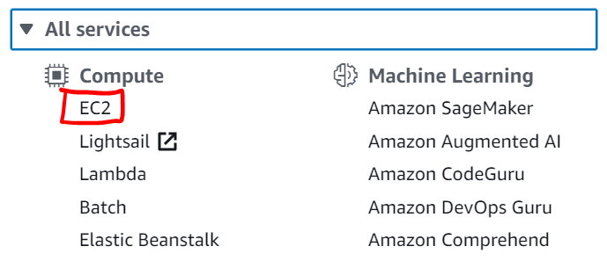

1. On the left menu, click **Instances**. You will see that an Amazon EC2 Instance called **Lab** has been launched in your lab.

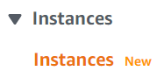

1. Take note of the **Availability Zone** for the **Lab** EC2 Instance. Also, select the **lab** instance and under the **Details** section copy the **Public IPv4 address**



1. On the left menu, click **Volumes.**
2. Click the orange **Create volume** button and configure the following:

**Volume Type:** General Purpose SSD (gp2)

**Size (GiB):** 1

**Availability Zone:** Select the same availability zone as your EC2 instance (From step 5)



1. Now, click the **Add Tag** button. Enter the following:

**Key:** Name

**Value:** My Volume



1. Click the orange **Create Volume** button
2. Wait for it to change from the Creating State to the **Available** state

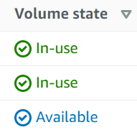

Attaching the Volume to an Instance

1. Click the block next to **My Volume**



1. Click the **Actions** drop-down, then click **Attach Volume**
2. In the **Instance** field, select the one named **Lab**

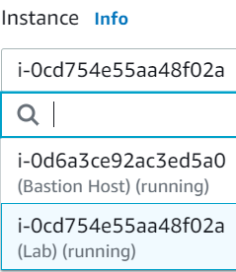

1. Click the orange **Attach volume** button

Connecting to Your Amazon EC2 Instance

1. If you are using windows follow this, if you’re using macOS or Linux, skip this:

Click the **Details** drop down and click the **Show** button. Click the **Download PPK** button and save the **labsuser.ppk** file

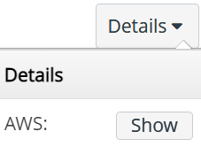 

1. Open **putty.exe** and click the **Connections** category. Under seconds between keepalives, enter **30.**

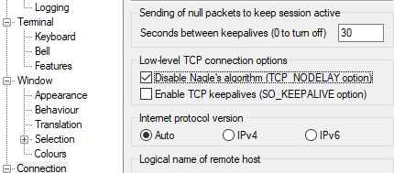

1. Click the **Sessions** category and under **Host Name** copy and paste the **Public IPv4 address** from step 5
2. Now, click the **Connection** section and expand **SSH.** Then click **Auth** and choose **Browse**. Look for the **labsuser.ppk** file you downloaded in step 15, select it, and click **Open.** Click **Open** again. Click **Yes** for the message that shows up

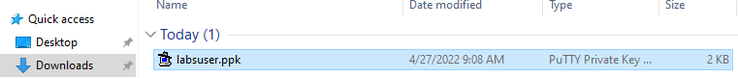

1. Under login, type **ec2-user**



Creating and configuring Your File System

1. Copy this into PuTTY to view the storage size. This shows you the original 8GB disk volume

df –h

1. Copy this text to create an ext3 file system on the new volume

sudo mkfs -t ext3 /dev/sdf

1. Copy this text to create a directory for mounting the new storage volume

sudo mkdir /mnt/data-store

1. Now, mount the new volume by entering the following:

sudo mount /dev/sdf /mnt/data-store

1. View the configuration file by doing:

cat /etc/fstab

1. To view the available storage, do:

df -h

1. The output should now contain this additional line:



1. Create a file on it and add some text to your mounted volume by entering:

sudo sh -c "echo some text has been written > /mnt/data-store/file.txt"

1. To verify that it was added, enter:

cat /mnt/data-store/file.txt

Creating an Amazon EBS Snapshot

1. In the AWS Management Console, on the left menu, select **Volumes**, then select **My Volume**
2. Click the **Actions** drop-down, and select **Create snapshot**
3. Click the **Add Tag** button and configure the following:

**Key:** Name

**Value:** My Snapshot

1. Click the orange **Create snapshot** button
2. On the left menu, click **Snapshots** to view your snapshot
3. On PuTTY, delete the file you created on your volume by entering:

sudo rm /mnt/data-store/file.txt

1. Enter the following to verify this:

ls /mnt/data-store/

Restoring the Amazon EBS Snapshot

1. To retrieve this data click **Restore** the snapshot

Creating a Volume Using Your Snapshot

1. In the **AWS Management Console** select **My Snapshot**
2. Click the **Actions** drop-down, select **Create volume from snapshot**
3. Select the same **Availability Zone** you used earlier
4. Click the **Add Tag** button and configure the following:

**Key:** Name

**Value:** Restored volume



1. Click the orange **Create Volume** button



Attaching the Restored Volume to Your EC2 Instance

1. On the left menu, click **Volumes**
2. Select **Restored Volumes**
3. Click the **Actions** drop-down and select **Attach volume**
4. On the left menu, click **Instances** and select the **Lab** instance
5. Click the orange **Attach Volume** button



Mounting the Restored Volume

1. To **create a directory** for mounting your new storage volume, enter:

sudo mkdir /mnt/data-store2

1. To **mount** your new volume, enter:

sudo mount /dev/sdg /mnt/data-store2

1. To **verify** that the volume you mounted has the file you created previously, enter:

ls /mnt/data-store2/

A file called **file.txt** should appear

You have finished this lab!

1. Click the **End Lab** button and select the blue **Yes** button.



**Conclusion**

In this lab you will, create an EBS volume, attach your volume to an EC2 instance, make a snapshot of your volume, make a new volume from your snapshot, and attach this new volume to your EC2 instance.